Thyristor Circuit
23 May 2017
7:52

Thyristor Circuit
In the previous tutorial we looked at the basic construction and operation of the Silicon Controlled Rectifier more commonly known as a Thyristor.

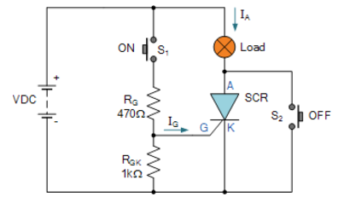

This time we will look at how we can use the thyristor and thyristor switching circuits to control much larger loads such as lamps, motors, or heaters etc.
We said previously that in order to get the Thyristor to turn-“ON” we need to inject a small trigger pulse of current (not a continuous current) into the Gate, (G) terminal when the thyristor is in its forward direction, that is the Anode, (A) is positive with respect to the Cathode, (K), for regenerative latching to occur.
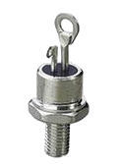
Typical Thyristor
Generally, this trigger pulse need only be of a few micro-seconds in duration but the longer the Gate pulse is applied the faster the internal avalanche breakdown occurs and the faster the turn-“ON” time of the thyristor, but the maximum Gate current must not be exceeded. Once triggered and fully conducting, the voltage drop across the thyristor, Anode to Cathode, is reasonably constant at about 1.0V for all values of Anode current up to its rated value.
But remember though that once a Thyristor starts to conduct it continues to conduct even with no Gate signal, until the Anode current decreases below the devices holding current, (IH) and below this value it automatically turns-“OFF”. Then unlike bipolar transistors and FET’s, thyristors cannot be used for amplification or controlled switching.
Thyristors are semiconductor devices that are specifically designed for use in high-power switching applications. Thyristors can operate only in the switching mode, where they act like either an open or closed switch and once triggered it will remain conducting. Therefore in DC circuits and some highly inductive AC circuits the current has to be artificially reduced by a separate switch or turn off circuit.
DC Thyristor Circuit
When connected to a direct current DC supply, the thyristor can be used as a DC switch to control larger DC currents and loads. When using the Thyristor as a switch it behaves like an electronic latch because once activated it remains in the “ON” state until manually reset. Consider the DC thyristor circuit below.
DC Thyristor Switching Circuit
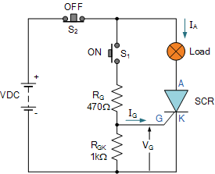

This simple “on-off” thyristor firing circuit uses the thyristor as a switch to control a lamp, but it could also be used as an on-off control circuit for a motor, heater or some other such DC load. The thyristor is forward biased and is triggered into conduction by briefly closing the normally-open “ON” push button, S1 which connects the Gate terminal to the DC supply via the Gate resistor, RG thus allowing current to flow into the Gate. If the value of RG is set too high with respect to the supply voltage, the thyristor may not trigger.
Once the circuit has been turned-“ON”, it self latches and stays “ON” even when the push button is released providing the load current is more than the thyristors latching current. Additional operations of push button, S1 will have no effect on the circuits state as once “latched” the Gate looses all control. The thyristor is now turned fully “ON” (conducting) allowing full load circuit current to flow through the device in the forward direction and back to the battery supply.
One of the main advantages of using a thyristor as a switch in a DC circuit is that it has a very high current gain. The thyristor is a current operated device because a small Gate current can control a much larger Anode current.
The Gate-cathode resistor RGK is generally included to reduce the Gate’s sensitivity and increase its dv/dt capability thus preventing false triggering of the device.
As the thyristor has self latched into the “ON” state, the circuit can only be reset by interrupting the power supply and reducing the Anode current to below the thyristors minimum holding current (IH) value.
Opening the normally-closed “OFF” push button, S2 breaks the circuit, reducing the circuit current flowing through the Thyristor to zero, thus forcing it to turn “OFF” until the application again of another Gate signal.
However, one of the disadvantages of this DC thyristor circuit design is that the mechanical normally-closed “OFF” switch S2 needs to be big enough to handle the circuit power flowing through both the thyristor and the lamp when the contacts are opened. If this is the case we could just replace the thyristor with a large mechanical switch. One way to overcome this problem and reduce the need for a larger more robust “OFF” switch is to connect the switch in parallel with the thyristor as shown.
Alternative DC Thyristor Circuit
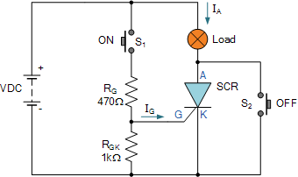

Here the thyristor switch receives the required terminal voltage and Gate pulse signal as before but the larger normally-closed switch of the previous circuit has be replaced by a smaller normally-open switch in parallel with the thyristor. Activation of switch S2momentarily applies a short circuit between the thyristors Anode and Cathode stopping the device from conducting by reducing the holding current to below its minimum value.
AC Thyristor Circuit
When connected to an alternating current AC supply, the thyristor behaves differently from the previous DC connected circuit. This is because AC power reverses polarity periodically and therefore any thyristor used in an AC circuit will automatically be reverse-biased causing it to turn-“OFF” during one-half of each cycle. Consider the AC thyristor circuit below.
AC Thyristor Circuit
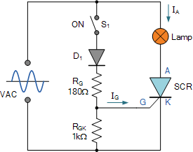

The above thyristor firing circuit is similar in design to the DC SCR circuit except for the omission of an additional “OFF” switch and the inclusion of diode D1 which prevents reverse bias being applied to the Gate. During the positive half-cycle of the sinusoidal waveform, the device is forward biased but with switch S1 open, zero gate current is applied to the thyristor and it remains “OFF”. On the negative half-cycle, the device is reverse biased and will remain “OFF” regardless of the condition of switch S1.
If switch S1 is closed, at the beginning of each positive half-cycle the thyristor is fully “OFF” but shortly after there will be sufficient positive trigger voltage and therefore current present at the Gate to turn the thyristor and the lamp “ON”.
The thyristor is now latched-“ON” for the duration of the positive half-cycle and will automatically turn “OFF” again when the positive half-cycle ends and the Anode current falls below the holding current value.
During the next negative half-cycle the device is fully “OFF” anyway until the following positive half-cycle when the process repeats itself and the thyristor conducts again as long as the switch is closed.
Then in this condition the lamp will receive only half of the available power from the AC source as the thyristor acts like a rectifying diode, and conducts current only during the positive half-cycles when it is forward biased. The thyristor continues to supply half power to the lamp until the switch is opened.
If it were possible to rapidly turn switch S1 ON and OFF, so that the thyristor received its Gate signal at the “peak” (90o) point of each positive half-cycle, the device would only conduct for one half of the positive half-cycle. In other words, conduction would only take place during one-half of one-half of a sine wave and this condition would cause the lamp to receive “one-fourth” or a quarter of the total power available from the AC source.
By accurately varying the timing relationship between the Gate pulse and the positive half-cycle, the Thyristor could be made to supply any percentage of power desired to the load, between 0% and 50%. Obviously, using this circuit configuration it cannot supply more than 50% power to the lamp, because it cannot conduct during the negative half-cycles when it is reverse biased. Consider the circuit below.
Half Wave Phase Control
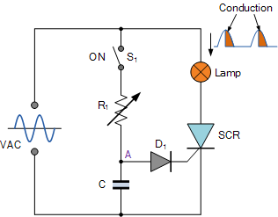

Phase control is the most common form of thyristor AC power control and a basic AC phase-control circuit can be constructed as shown above. Here the thyristors Gate voltage is derived from the RC charging circuit via the trigger diode, D1.
During the positive half-cycle when the thyristor is forward biased, capacitor, C charges up via resistor R1 following the AC supply voltage. The Gate is activated only when the voltage at point A has risen enough to cause the trigger diode D1, to conduct and the capacitor discharges into the Gate of the thyristor turning it “ON”. The time duration in the positive half of the cycle at which conduction starts is controlled by RC time constant set by the variable resistor, R1.
Increasing the value of R1 has the effect of delaying the triggering voltage and current supplied to the thyristors Gate which in turn causes a lag in the devices conduction time. As a result, the fraction of the half-cycle over which the device conducts can be controlled between 0 and 180o, which means that the average power dissipated by the lamp can be adjusted. However, the thyristor is a unidirectional device so only a maximum of 50% power can be supplied during each positive half-cycle.
There are a variety of ways to achieve 100% full-wave AC control using “thyristors”. One way is to include a single thyristor within a diode bridge rectifier circuit which converts AC to a unidirectional current through the thyristor while the more common method is to use two thyristors connected in inverse parallel. A more practical approach is to use a single Triac as this device can be triggered in both directions, therefore making them suitable for AC switching applications.

From <http://www.electronics-tutorials.ws/power/thyristor-circuit.html>

